**Project prototype**

NAME: ONYENZE CLINTON CHIEMENA

ID: K00253718

PROJECT: COLLEGE SOCIAL NETWORK

When you open this web application, the first page is the Sign-up page

**Sign-up page**

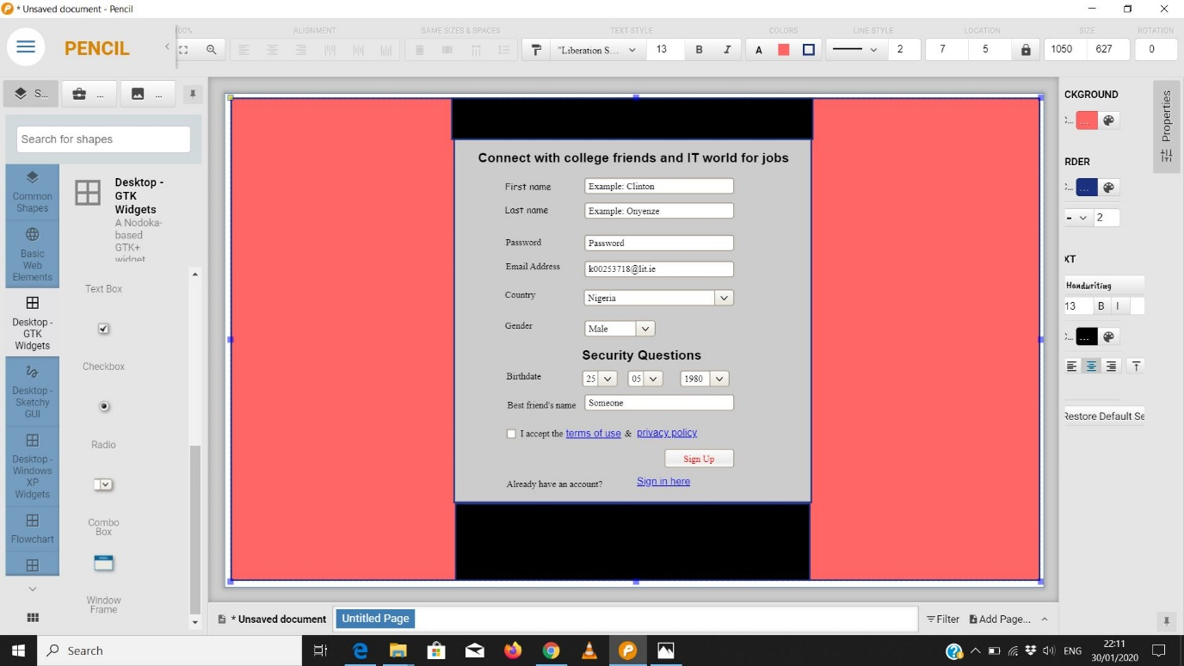

To create an account, the user is required to do the following:

1. Enter First Name
2. Enter Last Name
3. Create a Password
4. Enter Email Address
5. Click on the drop-down arrow to select country from the list
6. Click on the drop-down arrow to select gender from the list
7. Select Date of Birth using the drop-down arrow
8. Enter the best friend’s name
9. Read the terms of use and privacy policy before checking the box
10. Click on the Sign-up button to submit information for the account to be created.

If the user already has an account, they have to the hyperlink (sign in Here) to go to sign in Page.

**Sign-in page**

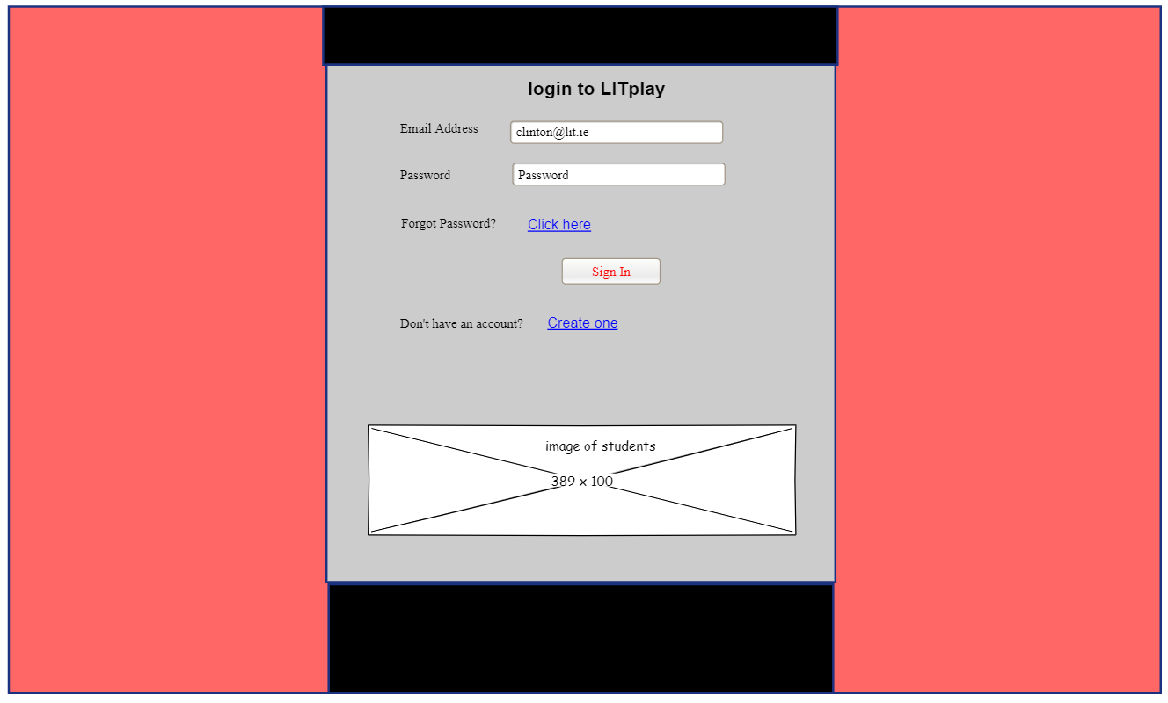

To sign in, the user is required to do the following:

1. Enter the account’s email address.
2. Enter the account’s password.
3. Click on Sign in Button to proceed.

If the user forgets password, they need to click on the hyperlink option (Click Here) to go to Forgot Password Page.

**Forgot Password Page**

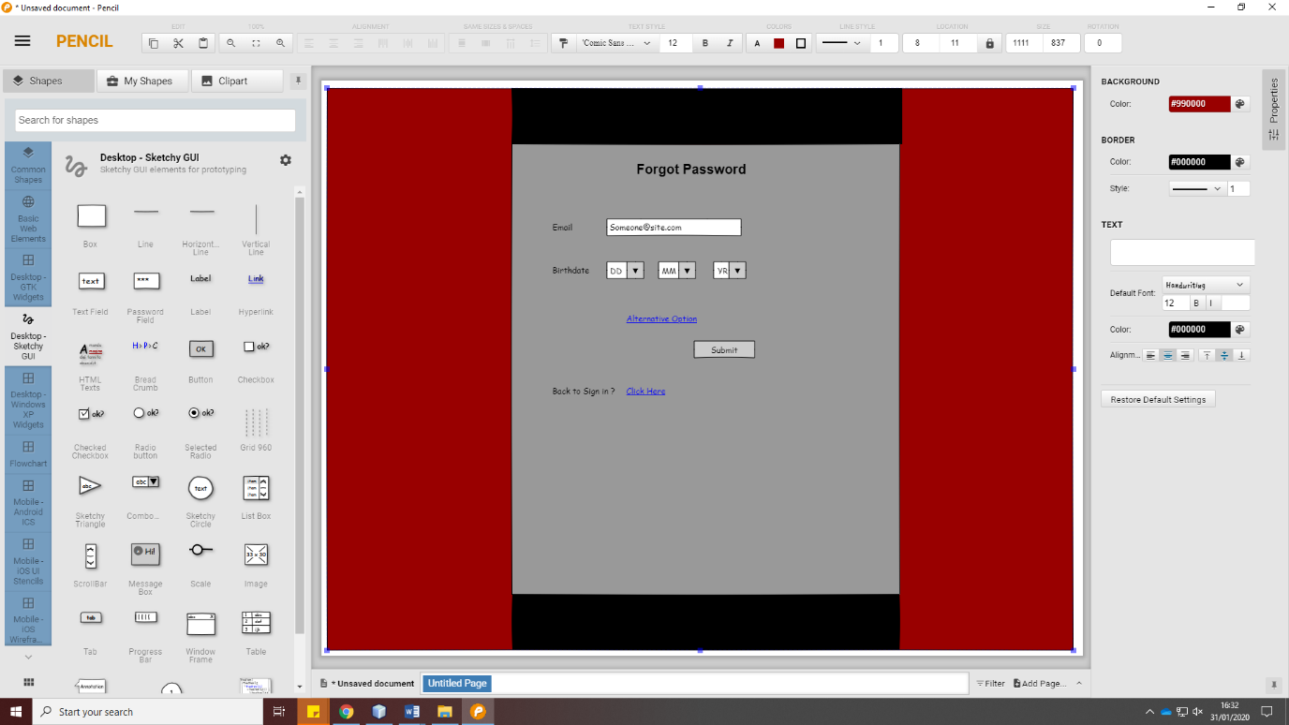

The user is required to do the following:

1. Enter the account’s email address.
2. Select Date of birth.
3. Click on Submit Button to process.

Alternatively, the user can also click on the hyperlink option (Alternative Option) to retrieve account password based on the second security question.

If the user could not remember birth of date, they need to click on the hyperlink option (Alternative Option) to retrieve account password based on the second security question.

**Alternative Forgot Password Page**

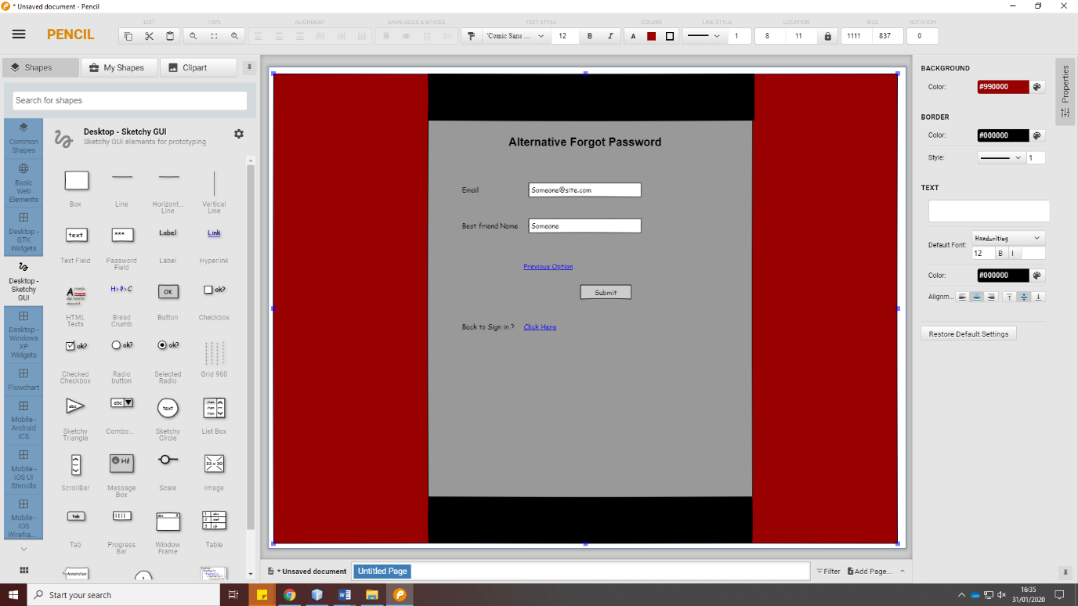

The user is required to do the following:

1. Enter the account’s email address.
2. Enter best friend’s name.
3. Click on Submit Button to process.

The users can update their Account Information on this page.

**Account Setting Page**

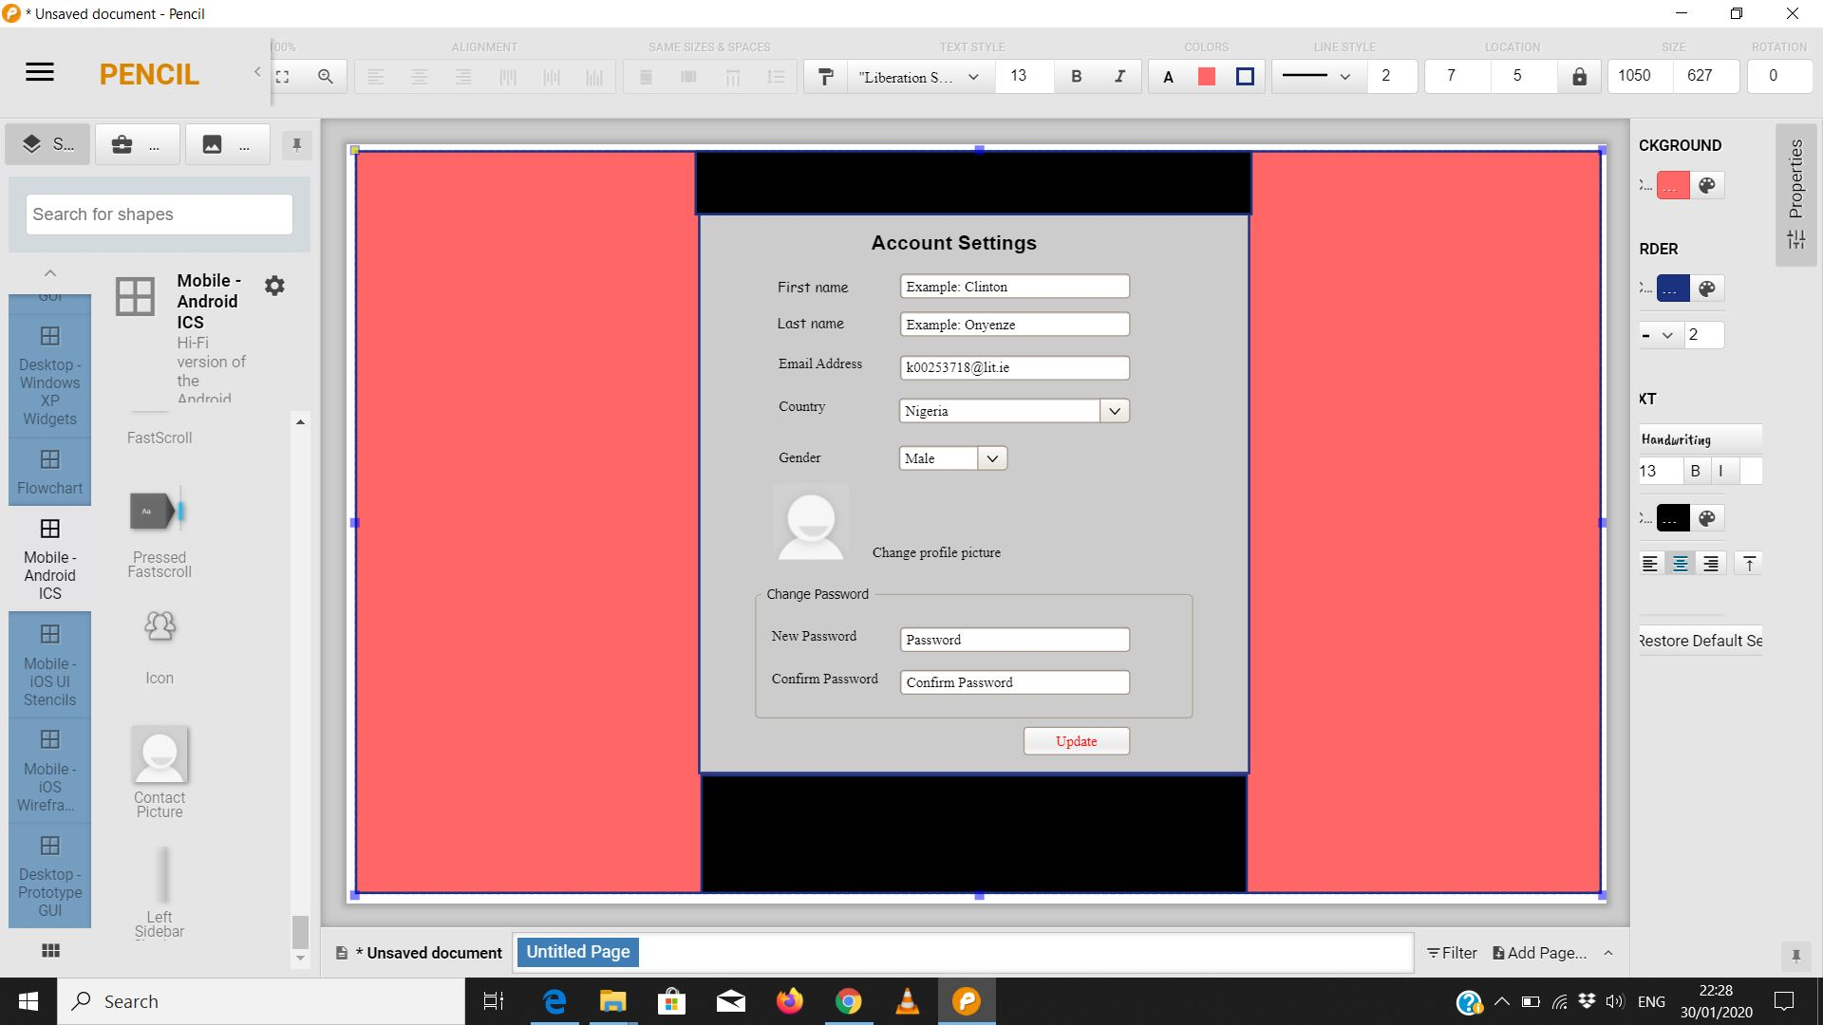

The user can edit the account information and click on Update Button to save.

**User Chat Room Page**

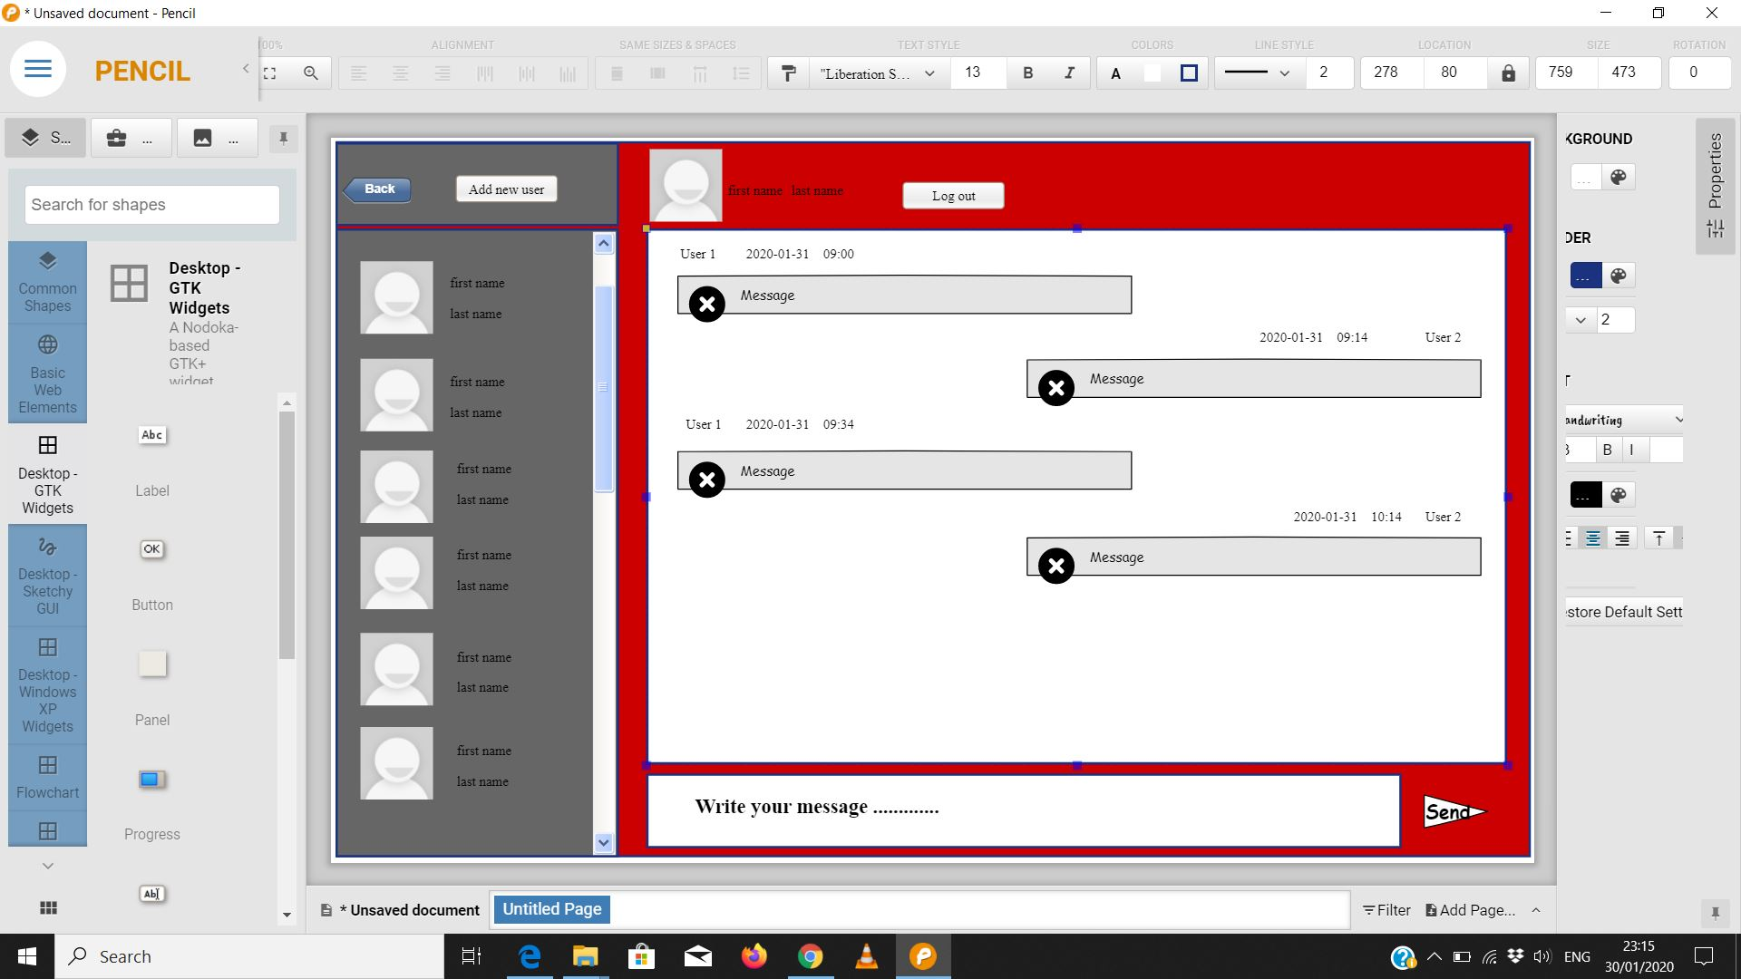

A user can send messages to another user

A user can receive messages from another user

A user can add a new user

**Work Placement Advert Page**

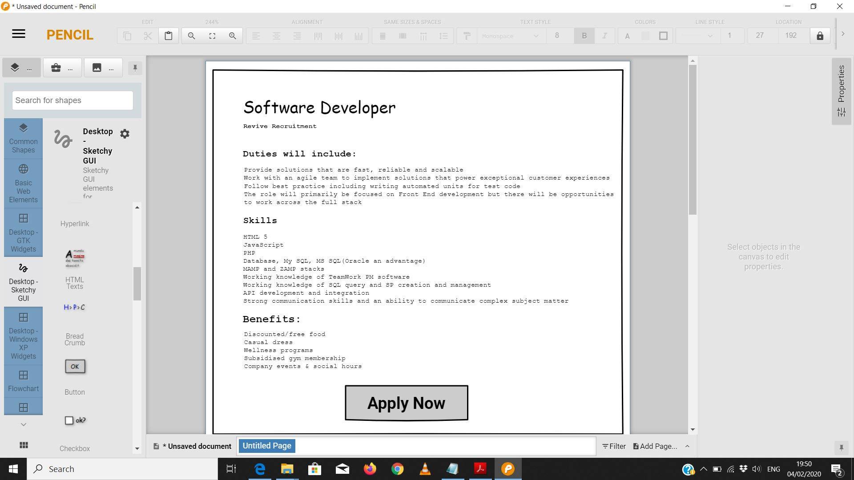

A Student can view available work placement and Click on the Apply Button to proceed with the application.

**Application Page**

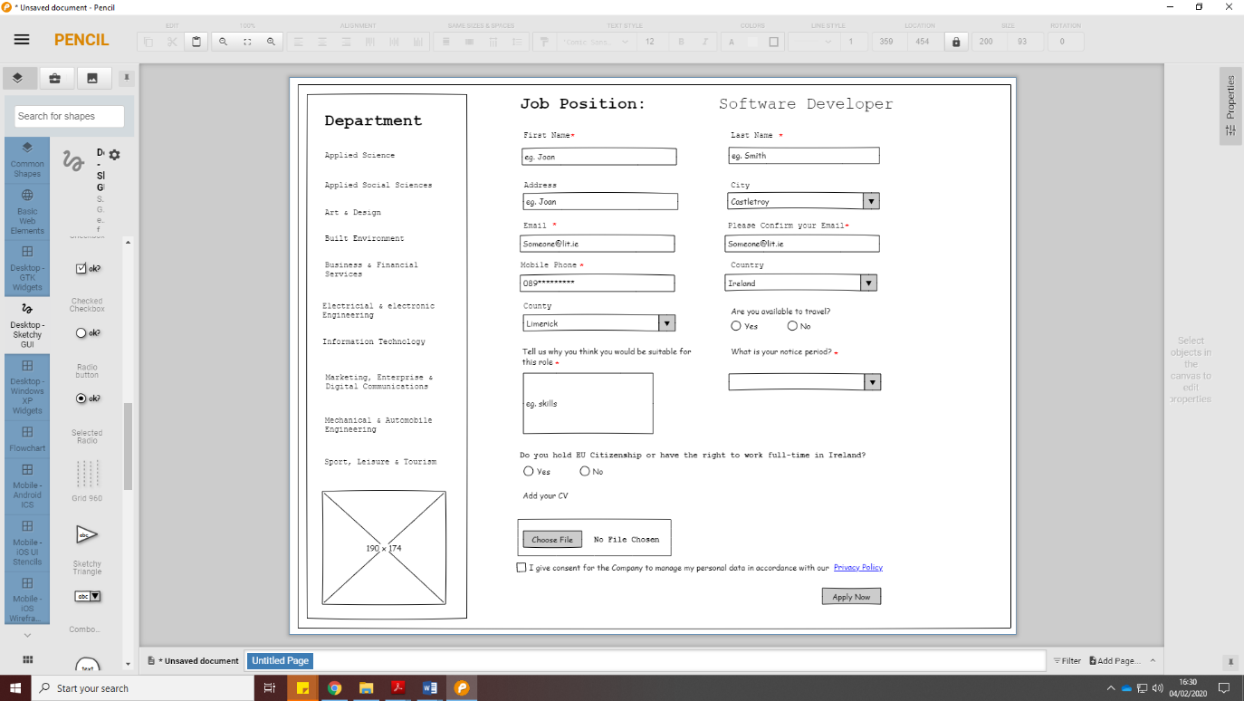

Students are required to enter the required information on the page and click on Apply Now to submit their application.